Carina House,  Sunrise Parkway  Milton Keynes, Bucks  MK14 6LS |  | p. +44 (0) 1494 871544  f. +44 (0) 1494 873118 |  | info@powersystemsinternational.com  www.powersystemsinternational.com

  - The Alders ELPS (FV000516-1)
  - Ref: E21-16051

Table of Contents

- Emergency Lift Power System (ELPS) – Series 5 3
Point of use power for Emergency Lifts
About the Product:
ELPS sizes
How the ELPS works..
Installation
Connecting the ELPS to the mains and to the lift
The emergency
- Relevant Part of Standards 5
- Lift Supply information 6
- Other Equipment Supply information 6
- Electrical Characteristic for the ELPS 7
- Operation of Lift 8
- ELPS Location Requirements 8
Within our scope of supply:
NOT in our scope of supply:
- Planned Location 9
- Benefits of ELPS over a standard UPS 10
- Details of Clients 10
- Lift Companies 11
- Recent Enhancements 11
- Important information 12
- Maintenance 12
ELPS scope of Works
Maintenance Contact
- Drawings 13
Inverter
Bypass Box Schematic
Source Information
- Relevant Portions of BS9999 16
BS9999:2017 - 45.9 Evacuation using lifts
20.4 Firefighters lifts
37.2.3 Electrical services for life safety and fire equipment
- Annex G 21
G.2.2 Power supplies
G.2.3 Control and operation of evacuation lifts
- BS8519 24
6 Power Supplies
Figure 1
7 Dual circuits / diverse routes
8 Fire protective enclosures for equipment
9 Automatic Change over devices

Emergency Lift Power System (ELPS) – Series 5

Point of use power for Emergency Lifts
Established in 1986 the company offers a power solution for meeting the emergency power requirements of Evacuation Lifts as defined in the Disability Discrimination Act of 1995 and the Regulatory Reform (Fire Safety) Order of 2005.
The Power Systems International team works closely with Lift manufacturers, Local Authority Fire Safety Officers, Consulting Engineers and Architects to determine the best cost effective means to deliver power “on demand” to a dedicated lift in an emergency when normal operations are halted.
The new Series 5 ELPS product is a “Black Box” point of use power system to feed VVVF lift hoisting or hydraulic systems.

About the Product:
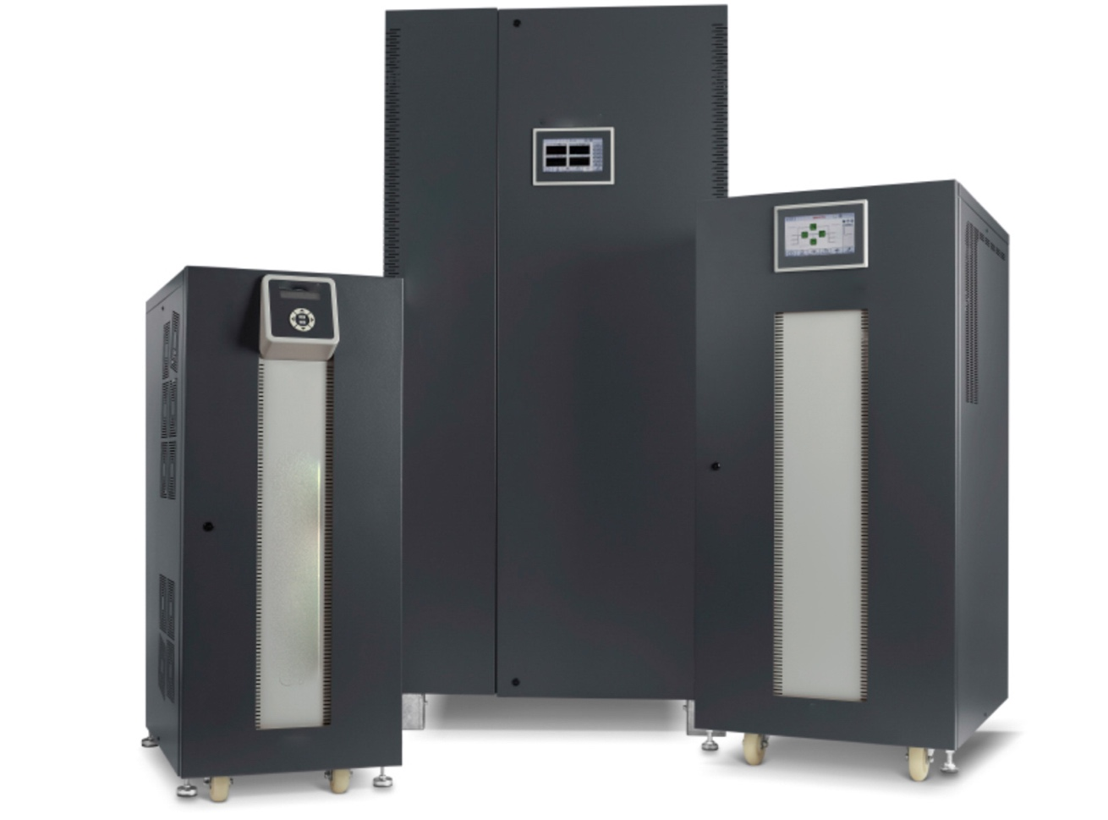
The ELPS Series 5 lift power system is designed for positioning as close as possible to the lift in a well ventilated indoors location.
Installation is quick and simple and therefore the cable runs are short and less exposed to the risk of theft, vandalism or sabotage, risks that exist with “centralised” back-up power systems.
The ELPS is supplied with a length of flexible cable for input and output terminated with a CEE17 plug and socket.
The package is provided with a “manual bypass box” for installation by the electrical contractor. This box is fitted with the mating plug and socket into which the flexible input and output cables of the ELPS are to be inserted.

ELPS sizes
The ELPS is available in sizings of 10, 15, 20, 30, 40, 60, 80 & 100kVA, though other sizes can be supplied upon request. All are suitable for use with mains power of 50Hz 400V three phase input and output with the output having a protective earth. The inverter is designed to accommodate the unpredictable load of most passenger lifts with weights up to 1600kg.
Our team will work with you to determine the correct sizing based on how many landing stops and starts per hour, how many passengers in the lift car in the upward elevation and on the descending journey. How long the lift will remain on a landing with the doors held open to allow disabled persons in wheel chairs be accommodated with dignity. The overall aim is to ensure that the ELPS can handle the required evacuation in the required period, which can be up to 180 minutes.

How the ELPS works..
In order to comply with the current legislation we provide a key operated switch (located by the lift). The key switch is intended so that only an authorised person can operate the lift in the event off a loss of power to cover emergencies.
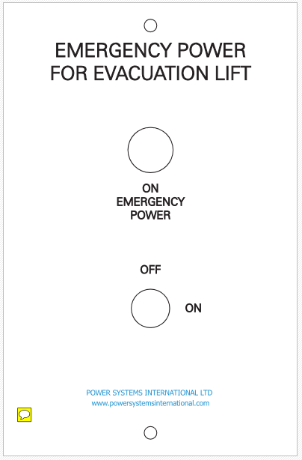
When the key is turned it starts the power to the lift much as turning the key in the car starts the engine.
The electrical contractor will need to install a suitable 5 cores signal cable from the ELPS to the remote control point.
The lift manufacturer will also need to take this signal into the lift control panel for the lift operator to observe the "on emergency power" status alarm.
The ELPS can be also be provided with an optional automatic control feature that allows the inverter to start upon sensing the loss of mains power (or other source) at the input terminals of the ELPS. A signal will be provided to indicate the inverter is operating.

Installation
The wall mounting dual purpose manual wrap around bypass box is as close as we can get to providing a “plug and play” simple and quick installation facility for connecting the ELPS product to the mains power and to the lift traction system.
The box will be delivered ahead of the ELPS unit so the electrical contractor can complete the installation of the box and fix all the cables without having the inconvenience of working around an obstructive “box” in the working area.
This wall mounting box is fitted with the plug and sockets into which the flexible input and output cables of the ELPS are to be inserted.

Connecting the ELPS to the mains and to the lift
Each unit is tested in our facility with the batteries that will be used for that specific installation. In this way we know that the unit works in that configuration before it leaves us.
The ELPS will be placed in its final operating place with the battery bank and correct internal connections, the plug and socket terminated flexible input and output cables stowed at the rear of the unit plugged into the bypass box fitted on the wall.
When the bypass switch is in the normal position the mains power feeds the ELPS input and battery charger. The ELPS output circuit is connected to the lift traction system and controller.

The emergency
There are many emergencies which may result in a building or part of a building needing to be evacuated. These emergencies are not just restricted to fire, earthquake tremors, explosion, a security threat, impact damage from crashing vehicle, flooding, storm damage, chemical, gas or other vapour release into the atmosphere.
The likelihood of one or more of these occurrences leading to an emergency call to evacuate will vary depending on the location and the use of the building. The majority of emergency considerations in the UK over the past 10 years have focused on fire, toxic fumes and smoke emission and the exceptional storm water flooding and mains power line failures over the winter of 2014.
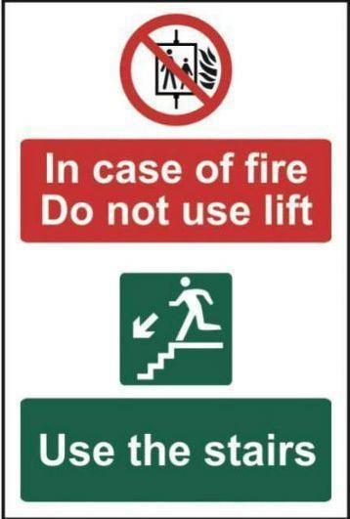

The familiar warning sign asking occupiers not to use lifts in an emergency is often specifically about a fire emergency. At the discretion of official policy relating to Public Buildings it might be permitted to use an appropriate lift under supervision for the evacuation of disabled persons where it is recognised there is a daunting and virtually impossible task to use exit flights of stairs for a quick exit of wheel chair bound persons.
The decision would have to be made based on the threat to life in using a suitable lift, possibly a lift that is a distance away from the reported emergency and where the risk is adjudged to be less than staying in the building or evacuating personnel into an unknown hazard area.
The ELPS will, however detect a mains failure and be automatically ready to deliver power to the point needed.
Where there was a fire in an electricity sub-station or in a distribution board feeding power to the building, this would most likely have initiated an alarm and the command for the system to start up and take over from the substation or Ring Main power supply.
building.

Relevant Part of Standards
The various standards call for the following:
Requirement | Source | Addressed
An inverter with enough power to run the equipment | See BS9999 37.2.3.3 Primary and secondary power supplies | Lift Supply information
An inverter with at 2 hour autonomy | See BS8519 6. Power Supplies | Lift Supply information
Diverse cabling Routes | See 7 Dual circuits / diverse routes | See Electrical Drawings
Manual control of the system | See BS8519 6. Power Supplies | The remote key avoids unintentional use and thereby maintains the integrity of the 2 hour autonomy

Lift Supply information

Other Equipment Supply information
Not currently in scope

Electrical Characteristic for the ELPS
.

Operation of Lift
The ELPS is a back-up unit. Should there be power to the lift then the unit will remain in back-up mode, until called upon, either manually or automatically. Unlike a standard UPS power is only taken from the unit on demand. Not only does this reduce the operation costs of the unit, but it also increases the life of the unit.
The unit comes with an automatic option. This detects the loss of power and automatically provides power within 40ms. The lift will then detect the power. The lift control panel can detect that the unit is on back-up mode, and the lift company should then create a display in the lift car, telling the users that the lift is on battery mode. The lift control panel should also display when the lift is on low battery. Both of these signals can be obtained from the lift via 0.5mm four wire cable.
The unit does come with the option of manual, or automatic. Manual mode will have an additional key operated switch, and will make a buzzing noise when in operation. Most users do not go or this option, because it requires another key, which can be lost, and something else to be considered in the event of an emergency. However, this is entirely down to your client.

ELPS Location Requirements
Ideally the unit should be located in a clean and dry room as close to the lift as is practicable. In this case the unit will need to be in a fire protected room with fire rating cables in and out of our By-Pass box.

Within our scope of supply:
i. We will fit the battery blocks into the battery enclosure and make off the inter cell cables and connectors, inter tier cables and connectors, cables from the battery terminals to the ELPS-15T(BASE) terminals.
ii. Remote wall mounting key operated ELPS-15T(BASE) control switch fitted with integral LED indication to show the lift is operating from the Standby Emergency Power Supply.
iii. Wall mounting external wrap around bypass unit fitted with input and output connectors.

NOT in our scope of supply:
The following site work is not in our scope of supply and should be completed by the electrical contractor or the lift equipment manufacturer or by other suitably qualified subcontractors to ensure the correct installation and operation of the equipment:
i. Installation of the remote control cable between the emergency lift and to the terminals on the rear of the ELPS-15T(BASE) system enclosure.
ii. Installation of the cable from the terminals of the ELPS-15T(BASE) system and connect to an indicator light “Emergency supply” within the EPS remote control switch unit. This indicates to the lift operator the ELPS-15T(BASE) is working.
iii. All power cables and electrical installation work

Planned Location
TBC

Benefits of ELPS over a standard UPS

Details of Clients
We have installations with a wide variety of institutions including, but not restricted to:
- Cambridge University;
- Oxford University;
- Peabody Estates;
- Lewisham Council;
- Natural History Museum;
- Lloyds of London;
- Houses of Parliament;
- Henley Business School;
- Bristol University;
- Travelodge;
- Premier Inn;
- Brighton University;
- Bangor University;
- Fredricks Special Needs School;
- Kirkleatham Special Needs School;
- Huntington Library;
- Cheltenham Ladies College; and
- Sydenham School.

Lift Companies
We have worked with a number of lift companies, from the very large, Kone, OTIS and Schindler, to the smaller companies like Sheridan Lifts, Knowsley Lifts and LX Elevators. Our unit is compatible with any lift manufacturer and can be retro fitted to any installation as well.
We do need to send a signal to the lift controller to indicate when the unit is operational and when it is on low battery. This is done via 4 core 1.5mm signal cable. However, we can also provide this via an illuminate box sited outside the lift at the evacuation level, as in our recent installation at Henley Business School. Moreover, we made some further adaptions to allow the facilities team, located 7 miles away in Reading, to remotely activate the ELPS.

Recent Enhancements
In moving from the Series 5 to the series 5, we have incorporated the following enhancements:
- Larger wheels for final placement, and for ease of moving during maintenance;
- More intuitive menu commands
- Integrated battery monitoring
- Increase ability to handle large in-rush currents
- RS232 / SNMP capability
- Reduce size, one third smaller than the Series 5; and
- Reduced weight, one third lighter than the Series 5

Important information
The end user must ensure that the unit is regularly maintained and tested fully to ensure that the unit meets the specifications outlined above. The unit must also be kept indoors in a relatively dust free environment and away from water.
It is important to minimize the cable lengths to reduce the risks of damage. The advantage of the ELPS unit is it can be located close to the source of power feeding the lift or even to fans needed for a safe refuge area.

Maintenance
Maintenance is advised every six months, and is usually expected to take one-man day per visit. Maintenance should only be undertaken by properly trained and approved individuals.

ELPS scope of Works

ELPS Full Maintenance Service
- Using a Fluke multimeter, record the phase to phase and phase to neutral input voltages.
- Perform a complete visual inspection of the equipment, including sub-assemblies, wiring harnesses, contacts, cables and major components.
- Check all nuts, bolts, screws and connectors for tightness and heat discoloration.
- Inspect for broken, brittle, damaged or heat stressed components and cables.
- Clean for any foreign material and dust from internal compartments.
- Perform a status check of alarm circuits.
- Perform an operational test of the system.
- Install or perform Engineering Field Modifications as necessary.
- Return the system to normal load and verify the output voltage. Calibrate as necessary.
- Review system performance with customer to address any system questions.

Internal Battery Maintenance Service
- Check integrity of battery mounting brackets and assemblies.
- Visually inspect battery system for: Swelling, leaks, loose foreign objects, overheated or corroded cables and connectors, loose connections on batteries and appropriate product labels related to safety and warning hazards.
- Clean and neutralize cell tops as required.
- Verify integrity of all battery terminal connections.
- Measure and record DC bus ripple voltage.
- Measure and record total battery float voltage.
- Record room ambient temperature.

Maintenance Contact
Maintenance can be arranged by calling Power Systems International Limited on 01494 871544 or by emailing us at info@powersystemsinternational.com

Drawings

Inverter
The same specifications apply to the units from 10Kva to 50Kva, and so will apply to the 50Kva system specified
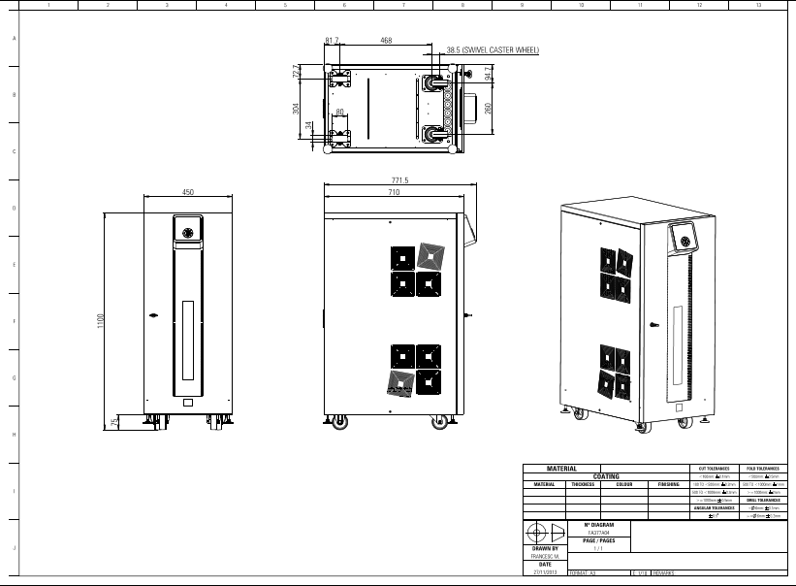

Bypass Box Schematic

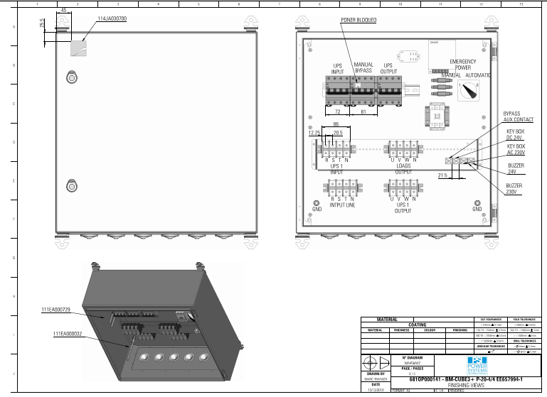
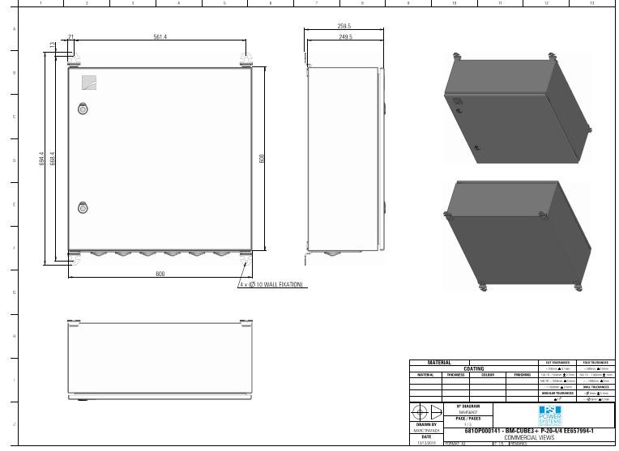
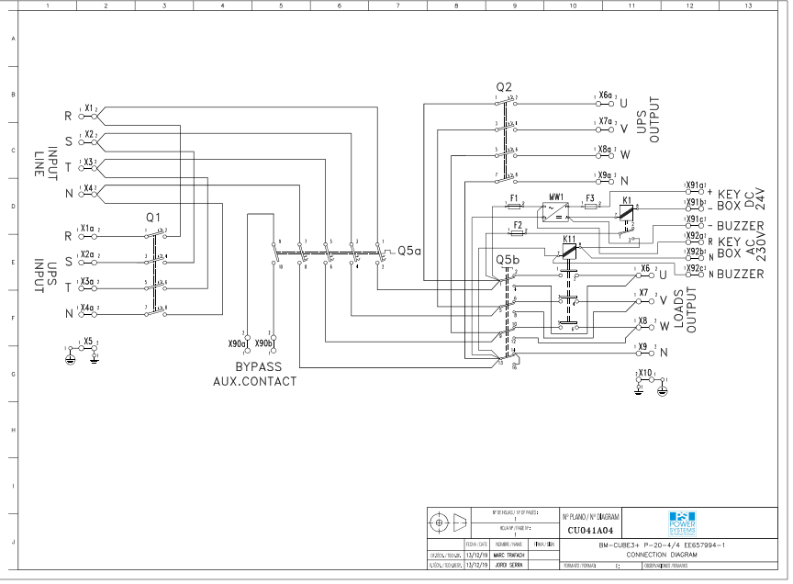
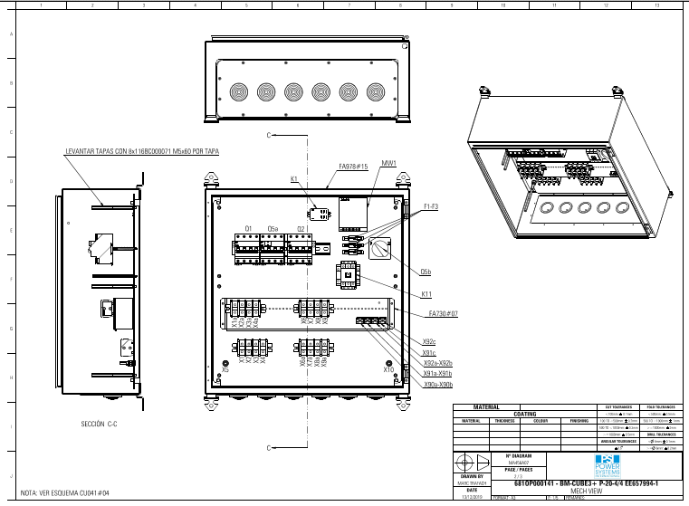

Source Information
TBC

Relevant Portions of BS9999

BS9999:2017 - 45.9 Evacuation using lifts
A lift to be used for the evacuation of disabled people should usually be either an evacuation lift or a firefighters lift, and should be operated under the control of the fire safety manager or a delegated representative, or otherwise by someone trained and authorized in the use of the lift. Evacuation lifts should be provided, constructed and operated in accordance with Annex G.
A lift that is not explicitly designed for evacuation may be used for evacuation, provided that it provides the same functionality as an evacuation lift. If this is to be considered as an option then a suitable risk assessment should be undertaken to evaluate whether the lift meets the recommendations given in Annex G (see also 3.72.2).
In the risk assessment all the features of fire protection in a building should be taken into account.
NOTE 1 For example, in a building with automatic sprinklers and significant compartmentation or smoke control, a risk assessment might conclude that a non-evacuation lift would be usable in the initial stages of a fire. Likewise, in a very large building, a non-evacuation lift which is remote from a fire in the initial stage might also be usable.
Issues that should be included in the risk assessment include thorough checks to ensure that:
- the interface between the lift control system and the fire detection and fire alarm system will support the evacuation management strategy;
NOTE 2 Where a fire detection and fire alarm system is connected to a lift control system according to BS EN 81-73:2016, operation of this would remove the lift from service.
- controlled operation of the lift will be possible during an evacuation;
- the power supply to the lift is likely to remain usable throughout the time required for evacuation;
- the lift enclosure and associated escape routes will remain free from the effects of fire, heat and smoke during the evacuation;
- there is a suitable communications system available to ensure that staff can use the lifts safely to evacuate mobility-impaired people;
- there is an alternative escape route available for situations when the use of the lift is not viable.

20.4 Firefighters lifts
COMMENTARY ON 20.4
A firefighters lift installation includes the lift car itself, the lift well and the lift machinery space, together with the lift control system and the fire and rescue service communications system.
The firefighters lift landing doors are fire doors.
If a firefighters lift does not serve the topmost storey of a building, the fire-fighting lobby on the topmost storey serves the fire-fighting stair only. If the topmost storey consists only of the firefighters lift machinery space, no lobby is necessary.
A firefighters lift, unlike a normal passenger lift, is designed to operate so long as is practicable when there is a fire in parts of the building beyond the confines of the fire-fighting shaft, as it is used to transport fire-fighters and their equipment to a floor of their choice.
The lift may be used in normal times as a passenger lift by the occupants of the building but, in order to prevent the risk of the entrance being obstructed when the lift is required to go into the fire-fighting mode, it is essential that it is not used for moving refuse, nor for moving goods. In buildings provided with a single lift, its use for the transport of goods needs to be avoided unless essential, lift lobbies need to be kept clear, and when the lift is used for moving goods it is essential that the doors are not propped open.

20.4.1 General
Firefighters lift installations should conform to BS EN 81-20 and BS EN 81-72.
The lift doors should be power-operated.
Fire-fighting shafts should be provided with firefighters lifts (see Figure 19) in:
a) buildings with deep basements (≥10 m), in which case the fire-fighting shaft should serve fire and rescue service access level and all storeys below it;
b) tall buildings (≥18 m), in which case the fire-fighting shaft should serve fire and rescue service access level and all storeys above it, although the firefighters lift need not serve any storey on which there is no entrance to any accommodation, or the topmost storey of the building if it consists exclusively of plant rooms;
c) buildings that are both deep and tall, in which case the fire-fighting shaft should serve all storeys, although the firefighters lift need not serve any storey on which there is no entrance to any accommodation, or the topmost storey of the building if it consists exclusively of plant rooms. Storeys below fire and rescue service access level may be served by a different firefighters lift from that serving the upper storeys, and any fire-fighting stair that serves levels both above and below ground level should be separated at ground level.
If a building contains separate units of accommodation with their entrances from common circulation spaces, e.g. as is the case with some flats, there should be access to each unit from a firefighters lift, either directly or via a common circulation space.
Where it is proposed that a firefighters lift is to run blind through several floors, early consultation should take place with the local fire and rescue service in relation to the setting up of a bridgehead by fire crews below the floor of fire origin.
If a fire-fighting shaft contains a firefighters lift, the fire-fighting stair in that shaft should serve every storey served by the firefighters lift.

37.2.3 Electrical services for life safety and fire equipment

37.2.3.1 Electrical power supplies to life safety and fire protection equipment
Since it is not possible to determine where a fire might start, all power supplies (primary, secondary and emergency) to life safety and fire protection equipment, and their associated control equipment back to the origin of the supply within the building, should be regarded as being within the hazard/risk area. Therefore great care should be taken in the design to ensure that power is available at all times.
In addition to the routing of cables, the positions of terminations, circuit protection facilities and control panels should be carefully planned, to ensure that these are also provided with protection from the effects of fire.
The electrical power supply to life safety and fire protection equipment should be separate from all other circuits in the building so that the failure of other equipment does not render the installation inoperative.
The selection, design and installation of these power supply systems should be in accordance with BS 8519, with additional protection measures as described in the present clause of BS 9999.
Any isolating protective devices supplying these systems should be clearly labelled and identified as to their purpose. They should be secured against unauthorized operation and should, except for maintenance, be kept locked-on. Additional warning labels should be provided, with their location and wording dependent on whether the isolating protective device is fed from the live side or the dead side of the main isolating device. If fed from the live side:
a) the label on each isolating protective device should read: “Warning: this supply remains live when the main switch is turned off”; and
b) a label should be placed on the main isolating device reading: “Warning: the…(state circuit)… supply remains live when this switch is turned off”.
If fed from the dead side, a label should be fixed to the main isolating device reading: “Warning: this switch also controls the supply to the …(state circuit)”.
Where a building control room or fire control centre is provided, monitoring facilities should be provided at that location to show, as far as is reasonably practicable, that power is available up to the final control point, e.g. motor contactor, to all fire safety systems.

37.2.3.2 Protected circuits for the operation of equipment in the event of fire
Wiring systems for both the primary and secondary power supply to electrical equipment required to operate in the event of fire should be of a type or installed in a manner such that, in the event of fire anywhere in the building, the circuits continue to operate and the cables maintain circuit integrity.
Wiring systems should meet the following specific recommendations.
a) The wiring systems should either:
1) consist of cables meeting the relevant life safety and/or fire safety performance objectives given in BS 8519; or
2) be protected against exposure to the fire by separation from any significant fire risk by a wall, partition or floor with a fire resistance of not less than that required for the building.
NOTE Where appropriate, conformity is for integrity and insulation from the side of the construction remote from the cable.
The mechanical protection of cables by conduit, ducting or trunking should not be assumed to give protection against fire.
b) The wiring systems should be separate from any circuit provided for any other purpose.
c) Jointing and termination methods should be chosen to minimize any reduction in reliability and resistance to fire below that of unjointed cable.
d) The wiring systems should be protected from mechanical damage.

37.2.3.3 Primary and secondary power supplies
To reduce the risk of the loss of electrical supply to fire protection systems that are required to operate continuously during a fire [such as those listed in h) below], a secondary power supply should be provided. This supply should be of sufficient capacity to maintain supplies to all life safety and fire equipment installations. The secondary power system should be designed to operate safely in fire conditions. The means for the provision of a secondary supply should include the overall electrical distribution system within the building, and also the power needs for other equipment requiring a secondary power supply.
NOTE 1 In some cases, where the power demand from a system is low (such as control systems for natural vent actuators), a secondary supply can be achieved by the use of back-up batteries.
NOTE 2 For legal and technical reasons, power supply companies have reservations about offering a power supply from a second substation to provide protection against the occurrence of a fault (unconnected with the fire) on the high-voltage distribution system. Accordingly, a generator or an independent power supply needs to be provided if protection against faults is required by the occupier.
The management procedures for the building should prohibit the isolation of circuits supplying power to the above mentioned equipment during a fire emergency.
Power supplies should meet the following specific recommendations.
- A secondary power supply independent of the primary power supply to the building, e.g. an automatically started generator or a supply from another substation, should be provided which, independently of the primary supply, is of sufficient capacity to maintain in operation for at least 3 h the following:
  - any powered smoke control systems (including systems using pressure differentials);
  - any fire and rescue service communication systems; and
  - any other fire protection or fire-fighting equipment, except automatic fire detection and fire alarm systems and evacuation lifts.
- b) The secondary power supply should be capable of providing the power supply for items a1), a2) and a3) within 15 s of the failure of the primary electrical supply.
- c) Where the secondary electrical supply is to be taken from a separate substation (whether utility or private) to that supplying the primary electrical supply, the following criteria should be met.
1) The electrical supplies to the two independent substations should be taken from two separate high-voltage supplies, and not originate from the same substation.
2) The failure of one substation should not lead to the failure of the other.
3) The two independent substations should be adequately separated. Where the substations are located within the building they serve, the following criteria should be met:
i) each substation should be enclosed within a fire-resisting structure having a minimum of 2 h fire resistance;
ii) the two substations should be located in two separate parts of the building.
4) Supply cables from the high-voltage substations should enter directly the high-voltage/low-voltage switchrooms and not pass through the
5) The two sets of supply cables should be adequately separated from each other to avoid a single fault affecting both supplies.
d) Cables supplying current to the life safety installations should be installed in accordance with BS 7671 and the manufacturer’s instructions. The cables should have an inherently high resistance to fire and be protected where necessary against mechanical damage. Cables, switchgear and other equipment transmitting the secondary power supply should be separate from those of the primary supply, or be physically protected so that a breakdown, or any cause of breakdown, on one supply would not lead to a simultaneous failure of the other supply.
NOTE 3 Further guidance on the selection of cables is given in BS 8519.
e) The primary and secondary power supply cables should be terminated in a changeover device located within the plant room(s) housing the life safety and fire protection equipment, or in the case of a firefighters lift, within the fire-fighting shaft.
NOTE 4 This is not to be confused with the lift well.
f) The changeover device should automatically effect the transition from the primary to the secondary power supply if the primary supply to the particular plant fails.
g) Any electrical substation or enclosures containing any distribution board, generator, powered smoke control plant, pressurization plant, communication equipment, and any other equipment associated with life safety and fire protection systems, should be separated from the building by construction with a duration of fire resistance of not less than 2 h.
h) Secondary power supplies should be provided for the following:
  - sprinkler pumps;
  - wet riser pumps;
  - firefighters lifts;
  - fire-fighting shafts (associated equipment and normal lighting);
  - fire-fighting intercommunications installations;
  - pressurization fans (air supply and pressure relief);
  - depressurization fans (air supply and pressure relief);
  - smoke control system;
  - evacuation lifts.
NOTE 5 For evacuation lifts, it is often acceptable to provide a supply from a single intake to the premises, provided that in all other respects the configuration of the circuits within the building and the other fire protection measures detailed above and in BS 8519 are as recommended. A secondary supply from a separate substation or standby generator is not required unless that supply arrangement is necessary for other fire safety reasons (e.g. to supply a firefighters lift or smoke control system). More detailed recommendations are given in Annex G.

Annex G

G.2.2 Power supplies
The primary electrical supply should be obtained from a sub-main circuit dedicated to the evacuation lift and independent of any other main or sub-main circuit. Other lifts in the same well may be fed from the same supply, provided that the capacity is adequate for the purpose and that arrangements are such that a fault occurring in any other lift in that well or their power supplies do not affect, in any way, the operation of the evacuation lift.
To ensure that operation of the evacuation lift is maintained for as long as required for the evacuation of disabled people, an alternative power supply should be provided. This allows continued operation of the evacuation lift in the event of failure of the primary supply; whether by fire in the building or for some other reason. The alternative supply should be one of the following.
a) A secondary power supply, such as a generator or supply from a separate utility, meeting the recommendations in BS 8519. Where a secondary supply is specified for other life safety systems then it should be of adequate capacity and used to supply the evacuation lift.
b) A separately fused circuit fed directly from the main incoming electrical supply to the building, located in a fire-protected enclosure. Thereafter, the recommendations in BS 8519 should be followed for the configuration of the circuits within the building and fire protection measures. The adoption of such an alternative supply route should be subject to a risk assessment, taking factors into account such as the travel of the lift, the implications of a failure of the primary supply, the alternative evacuation planning, etc. Evacuation lifts using such an alternative supply route through the building should have an automatic rescue device which, in the event of a power failure, allows them to move automatically to an adjacent storey and open their doors to allow their passengers to escape.
The cables transmitting the secondary supply or alternative circuit should be separated from those of the primary supply and routed through areas of low fire risk, or should be physically protected so that a breakdown, or any cause of a breakdown, on one supply cannot lead to simultaneous failure of the other supply. Any power switches or isolators should be clearly identified. Labels should be provided at the main switchboard and at the incoming power supplies indicating the presence, purpose and location of the two circuits. The arrangements for cable specification, routing and installation, automatic changeover devices between primary and secondary circuits and the fire protection of any enclosures should be in accordance with BS 8519.
Battery inverters should not be used as secondary power supplies for fire safety purposes, unless it can be demonstrated that:
1) this power supply is capable of operating the lift at normal speed; and
2) it has sufficient capacity and endurance to enable the lift to perform sufficient cycles to serve and evacuate every refuge associated with the shaft, at one refuge per cycle (one cycle being movement from final exit level to a refuge and back to the final exit level). Movement to the level from which the authorized person will take control of the lift should also be included. The capacity should be calculated with allowance for the batteries’ supply capacity at the end of their design life.
Where it is reasonably foreseeable that the refuges will be used by more than one user, and the size of the evacuation lift is such that more than one cycle would be required to evacuate each refuge, the battery capacity should be increased accordingly.
Any electrical substation, distribution board, generator, hydraulic pump or other apparatus should be protected from the action of fire in the building for a period not less than that specified for the enclosing structure of the evacuation lift installation and in accordance with the general principles of structural fire protection for a lift machine room or machinery space.

G.2.3 Control and operation of evacuation lifts
On the operation of the “Evacuation Lift” switch, or on a signal from a fire detection system, the evacuation lift should isolate all car and landing call controls and return to the final exit level and park with its doors open.
Once at the final exit level and once the “Evacuation Lift” switch has been operated, the car controls should be enabled; the evacuation lift should then operate only in response to the car controls and the communication system provided should be in operation.
The lift car should be taken only to those levels where a person is in need of assistance.
To manage this system adequately, a sufficient number of competent staff (and deputies) should be designated and should be capable of carrying out the necessary duties quickly and efficiently at all times during which the building is occupied.
The evacuation procedure for people requiring assistance should begin at the first warning of fire. In premises where there is a two-stage fire warning system, this should be on the sounding of the “alert” or “first-stage” alarm.
Except in two-storey buildings, some form of emergency voice communication system should be provided to enable the rapid and unambiguous identification of those locations (e.g. refuges) where people requiring assistance with evacuation might be waiting, from a control point, and the relaying of this information to the person operating the evacuation or firefighters lift car. This system may also be used to reassure those waiting that assistance is on its way.
NOTE 1 Communication systems recommended for firefighters lifts (see 20.4) are not sufficient for an evacuation lift.
The cabling for such emergency voice communication systems should be fire-protected and may be run within the lift well. The communication system should have a back-up power supply sufficient to operate it for the planned evacuation time, or be fed from the secondary supply.
Staff immediately available at the final exit level (possibly security or reception staff) should be designated and trained as evacuation lift operators. The duties to be undertaken by a designated member of staff, immediately on receipt of a fire alert signal, should include the following.
a) An operator designated to take control of the lift should operate the evacuation lift switch, and should:
  - determine the storey and part of the building indicated as the location of the fire;
  - determine the storeys at which people are awaiting assistance; and
  - take control of the lift and proceed to move people requiring assistance to the final exit level.
b) A designated person should ensure that:
  - any people requiring assistance in the storey for which that person is responsible move to the nearest refuge (lift lobby, etc.) to await the lift; and that
  - the person controlling the evacuation lift is aware that a person or persons is/are waiting for the lift.
Unless a different order has been agreed with the fire authority, evacuation should normally be in the following order:
    - the fire floor;
    - the floor immediately above the fire floor;
    - other floors above the fire floor starting at the top storey;
    - all remaining floors.
The actual fire conditions, however, might necessitate changes in the planned sequence, and this should be taken into account.
At final exit level, help should be available to assist passengers from the lift thus permitting a rapid vacation of the car and avoiding congestion near final exits.
If an evacuation lift fails to arrive at a landing, or access to it at any level is obstructed by the fire, it is necessary to use a stairway. The best method of negotiating stairs should therefore be determined, and practised if necessary.
NOTE 2 If the lift itself remains safe to use it might only be necessary to descend to the storey below using the stairway and from there continue the descent by lift.
When the fire and rescue service arrives, the officer in charge should be briefed by the designated member of staff coordinating the evacuation on both the position and circumstances of the fire, and the progress of the evacuation.
Subsequent priorities for the use of evacuation lifts and firefighters lifts should then be as decided by the fire and rescue service.

BS8519

6 Power Supplies
Where electrical services in the building are essential to maintain the operation of the life safety and ﬁre-ﬁghting systems, a secondary power supply, e.g. an automatically started standby generator (see Figure 1) or an alternative utility supply (see Figure 2) from another external substation, should be provided which will, independently of the primary supply:
a) be of sufﬁcient capacity to maintain any system in operation for at least the ﬁre survival time identiﬁed in Clause 5 for the appropriate system and type of building; and
b) be capable of operating safely in ﬁre conditions for the appropriate period of time.

Figure 1
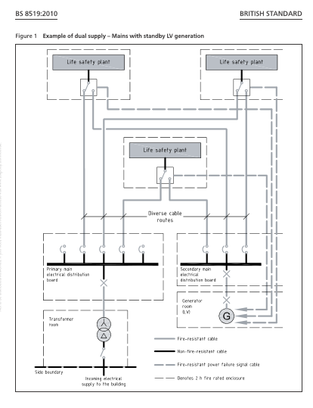

7 Dual circuits / diverse routes
A fundamental principle of this British Standard is that both the primary and the secondary supplies should be protected against ﬁre and water damage (see Clause )and separated from each other by adopting diverse cable routes.
The diverse cable routes for the power supplies should be separate from any non-life safety/ﬁre-ﬁghting system circuits that could be detrimental to the operation of the life safety and ﬁre-ﬁghting system circuits.
Where the HV supply cables from the intake rooms have to be routed through the building to HV switchrooms and transformer rooms, both the primary and secondary supply cables should be protected against the risk of damage by exposure to ﬁre and water
When designing diverse cable routes, account should be taken of any ﬁre risks located within the area of the cable route. Where the diverse routes come together in the same area, they should be separated from each other by a partition with aﬁre resistance period of at least the ﬁre survival time identiﬁed in Clause 5 for the appropriate system and type of building.
In the case of two low voltage cables (i.e. 400 V3-phase), the cables should be selected for the appropriate ﬁre survival time (see Clause 11 for cable selection and Clause for ﬁre survival times).

8 Fire protective enclosures for equipment
Any electrical substation or enclosures containing any of the following equipment should be separated from the building by construction protected against ﬁre and water damage for a period of at least 2h
- distribution boards;
- motor control panels;
- smoke control plant;
- pressurization plant;
- communication equipment;
- automatic changeover devices, with their associated switchgear;
- any other equipment associated with life safety and ﬁre-ﬁghting

9 Automatic Change over devices
The primary and secondary power supply cables should be terminated via a changeover device (automatic transfer switch or similar) located within the plant room(s) housing the life safety and ﬁre-ﬁghting equipment, or in the case of a ﬁre-ﬁghting lift, within the ﬁre-ﬁghting shaft.
The changeover device should automatically effect the transition from the primary to the secondary power supply in the event of the loss of the primary supply to the plant.
Changeover devices should conform to BS EN 60947-6.
Where the availability of the life safety and ﬁre-ﬁghting equipment is conditional to the occupation of the building, a bypass arrangement should be incorporated to enable the changeover device to be maintained without loss of service from the critical plant.

